## Basics

### Open Source

firefox

VLC

Blender

GIMP

Audacity

Wordpress

### Architecture

### File Architecture

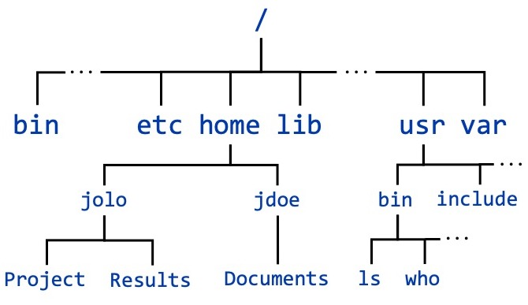

## 

## Unix Linux BSD

Unix

1960s

AT&T Bell

Ken Thompson

Dennis Ritchie & Brian Kerningham

MULTICS

UNICS

Unix

macOS - darwin

Solaris

IBM AIX  
HPUX

BSD

Berkeley Software Distribution

1970s

vi editor

C shell

TCP/IP

1984

Richard Stallman

Free Software Foundation

GNU

GNU Not Unix

1990s

Linus Torvalds

GPL

stability

security

Debian kernel

Linux distributions

MX Linux

Manjaro

Mint

Ubuntu

Debian

Suse

Raspbian

RedHat

BOSS

### build & development

Readline

X Window System

x11

x

Wayland

glibc

GNU C library

uClibc

BusyBox

Swiss Army Knife of embedded Linux

uname -a

## 

## Command Line Interpreter

Shell

ksh

tcsh

zsh

Fish

bash

### structure

command

command + options

command + arguments

### Basic commands

ls

-l

-a

-i inode

pwd

clear

cd

dir_name

.. parent

~ home directory

whatis

man

1 commands

2 system calls

3 functions

7 signals

## Files & Directories

absolute

relative

### basic commands

mkdir

cd

cp source dest

mv (move)

(rename)

rmdir delete empty directory

rm delete a file

rm -r delete directory recursively

#### viewing

cat

head

tail

less

nl

### editors

nano

vi (vim)

gedit

atom

sublimetext

vscode

emacs

notepad++

### redirection

>

>>

## vi (vim)

### modes

#### insertion

i

#### command

esc

:w save

:wq save & quit

:q! quit without saving

:w! save as

yy copy a line

4yy copy 4 lines

yiw copy a word

p paste after the cursor

P paste before the cursor

dd deleting a line

cut

diw delete 9cut) word under the cursor

3dd delete 3 lines

u undo

ctrl + r redo

/pattern search for the pattern

n move o the next pattern

search & replace

:s

substitute in current line

:s%

substitute in all lines

/%s/old/new/g

replace all old with new

/%s/old/new/gc

replace all old with new with confirmations

/%s/old/new/gci

replace all old with new with confirmations, case insensitive

(ignore case)

## Users & groups

### commands

su

### root

super user

* full read/write/execute privileges
* creating or installing software
* modifying files & settings
* creating or deleting users and data

sudo (superuser do)

yearly_training.data

modes of a file:

read write execute

user group others

r w r w r -

marvels.txt

r w - r - - r - -

1 1 0 1 0 0 1 0 0

6 4 4

644 to 646

u user

g group

o others

r read

w write

x execute

-w remove write for all

g+x add execute permissions for group

### commands

chmod

chown

chgrp

useradd create/add a user

passwd

groupadd create a group

usermod modify user settings

rwx rwx r-x

775

## intermediate commands/concepts

### wc

-l

-c

-w

### pipe |

grep

-n

### tar archive

TAR TapeARchive

gzip

tar.gz

.tgz

bzip

.tar.bz2

tar xf file.tar -C directoryname

tar xf file.tar.gz -C directoryname

tar xf file.tar.bz2 -C directoryname

unzip file.zip -d directoryname

### links

2 kinds:

1. hard links
2. symbolic (short) links

#### links (for directories)

from linuxFTW cd sample

from dir1 cd ..

from dir2 cd ..

from dir3 cd ..

from anywhere cd /home/john/Desktop/linuxFTW/sample

5 hard links

## shell expansions

### wild cards

* placeholder for 0 to n number of characters

? single character

{ }

### shopt

shopt

-s set

-u disabling

extglob

extended globbing

## process

pid



### file descriptor

temporary number

lowest available

0 stdin

1 stdout

2 stderr

threads

lwp

### commands

#### ps

pidof

nice

renice

kill

pkill/skill

pgrep

columns:

process state

user name (uid)

gid

system time at launch

%CPU

CPU time

blocked signals

running since

number of threads

pid

ppid

RSS

VIRT (VSZ)

%memory

priority

TTY (terminal)

list of files

options

ps

-a hidden process in the shell

-A all process in the system

-aux all process with a different set of columns

-ef all process with a different set of columns

-ax all process with a limited set of columns

-C search for a process by name

-o customise the output columns

pid

ppid

tty

%cpu

%mem

time

stime

etime

cmd

pri

user

stat

nlwp

lwp

## states of a process

run R actively using the CPU

sleep (wait) S waiting for an event to happen

waiting for a timer to get over

stop T paused & sent to the background

kernel I kernel based process

## signals

| signal | can be sent from keyboard? | can be ignored? | default action |
| --- | --- | --- | --- |
| SIGTERM | no | yes | terminate the process |
| SIGINT | ctrl + C | yes | terminate the process |
| SIGKILL | no | no | terminate the process |
| SIGSTOP | ctrl + Z | no | put into “stop” state |
| SIGCONT | no | yes | continue a process |

kill -9 6247

kill -SIGKILL 6247

SIGTERM 15

SIGINT 2

SIGKILL 9

### commands

kill

pkill/skill

## Background Process & jobs

1. background of the system

daemon

1. background of the shell

### jobs

fg

bg

## Network

### MAC address

Media Access control

09:12:3a:4d:5f:20

### IP address

32 bit

220.189.40.212

IPv4

127.0.0.1 localhost

IPv6

## DNS

Domain Name System

host

dig

nslookup

ping

packet internet groper

## remote connections

FTP

File Transfer Protocol

Telnet

SSH

Secure Shell

RDP

Remote Desktop Protocol

HTTP

### SSH

Secure Shell

Secure Socket Shell

OpenSSH

ssh remote_username@remote_host

client → → sshd server

need:

* IP address
* user ID
* password

### SCP

secure copy

scp avengers.txt shobhit@10.0.0.156:/Users/shobhit/desktop/qualcomm/linux101

-r Recursively copy entire directory

-l limit

limited the bandwidth

## Shell Script